DEEP LEARNING: Charity Funding Predictor

In this analysis, we are using neural networks are used to determine if the applicants would be good candidates for funding the Alphabet Soup non-profit foundation. First started with taking the dataset and removing all insignificant data such as EIN and NAME and classified the data into testing and training set. From there we will compile, train and evaluation the binary classification model to calculate the loss and accuracy. Each value was then analyzed to see if the bin was successful or non-successful. For compiling the model, we used Neural Networks and created hidden nodes, and lastly outputted the loss and accuracy of the unique dataset.

These were the results of the model using test data:

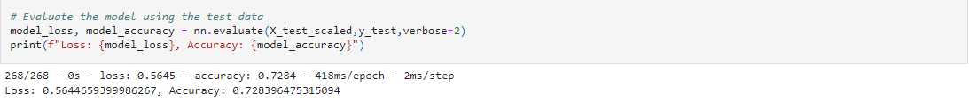

Below is the deep neural net model generated only using two hidden layers:

From the results you can see that this is a multi-class classification.